

HELP MANUAL

### FOR : HODEK Vibration Technology

### Provided BY



### APPOINT 2 MEE

### Office No 524,5th Floor ,Amanora Chember,Amanora Part Town Hadapsar Pune Maharastra

1. **Introduction**
2. **Login** 
   * 1. **Screen**

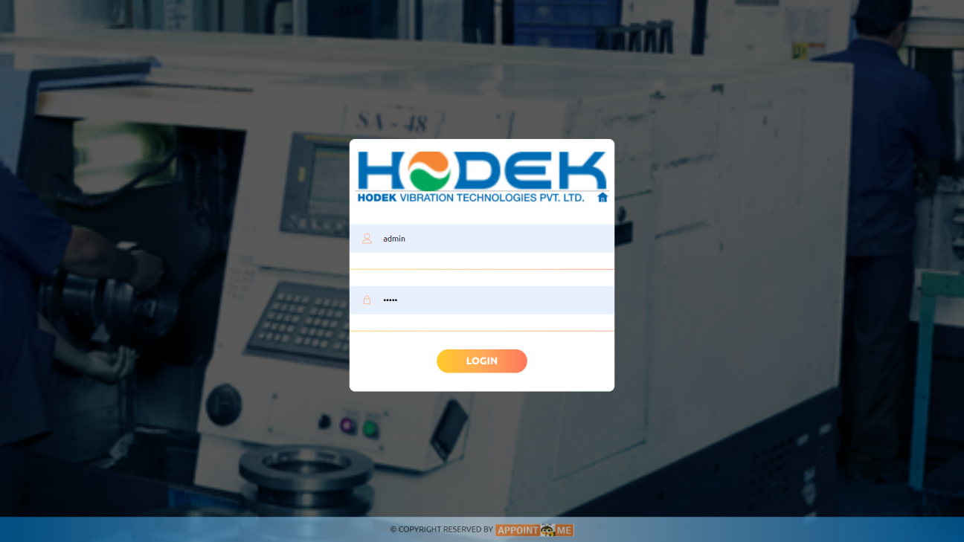

*Image No : 1*

* + 1. **Description**

As seen as in Image No:1 this will be main starting page of application ,has to be enter login credential such as username and password to enter into system ,username and password will be provided by admin /or for admin credential will be provided by us

1. **Dashboard**
   * 1. **Screen**

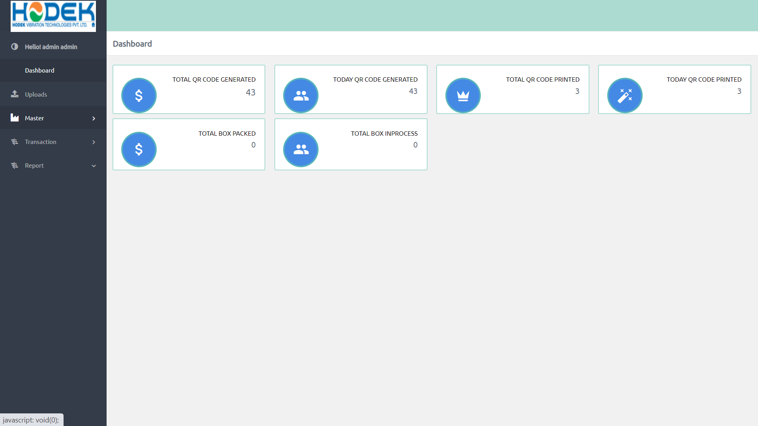

*Image No : 2*

* + 1. **Description**

This will be a home page of application ,after login successful you will routed to here, as showing in *Image No : 2* you see outrage of application and transaction count such as following to check productivity

1. Total QR Code Generated
2. Today QR Code Generated
3. Total QR Code Printed
4. Today QR Code Printed
5. Total packed Box
6. Total Box in picking
7. **Master**
   1. **Component** 
      1. **Screen**

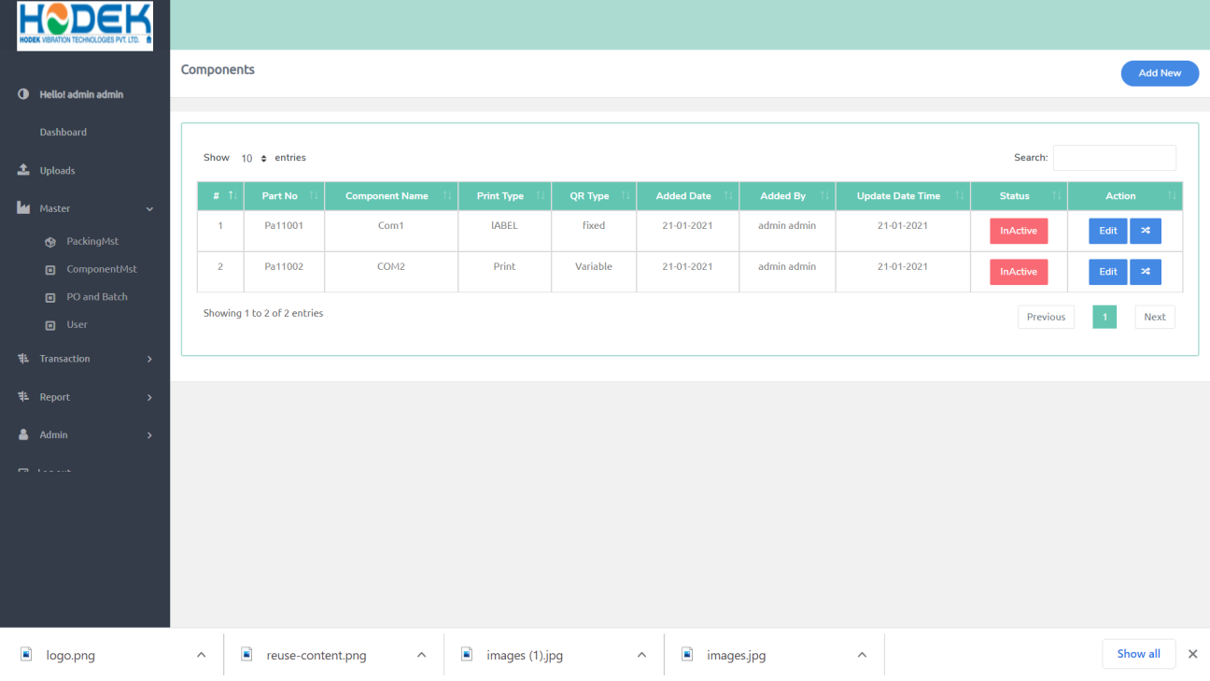

*Image No : 3*

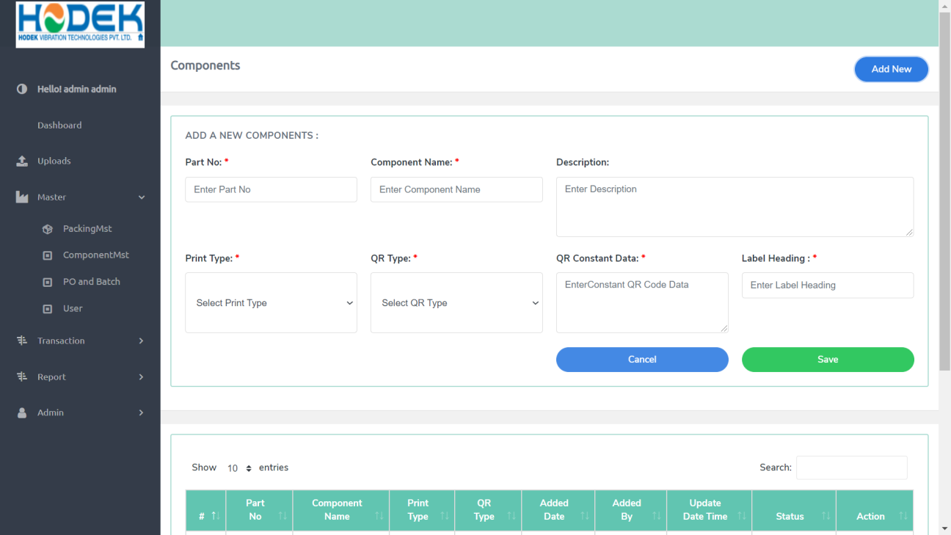

*Image No : 4*

* + 1. **Description**

This will used to managed component module ,from here login user can view component details add new updated and etc,

As in *Image No : 3* this page will come on, when click on master --> Component,first of all in this page you can see list of component,from here you can change a status of component and as will as update details of exiting component

As in *Image No : 4*  you can add new component on click of “Add New ” on top of page after click on add new this page will open ,after that you need to add component details ,after that need click save button ,then you get status toaster

* 1. **Packing Box** 
     1. **Screen**

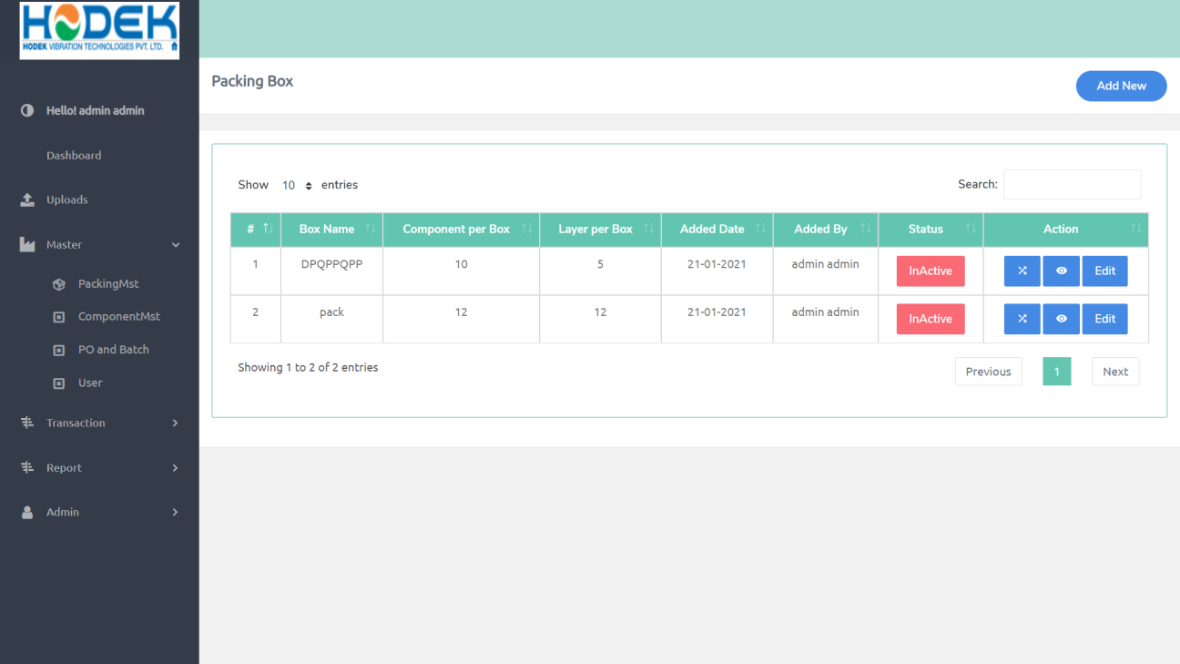

*Image No :5*

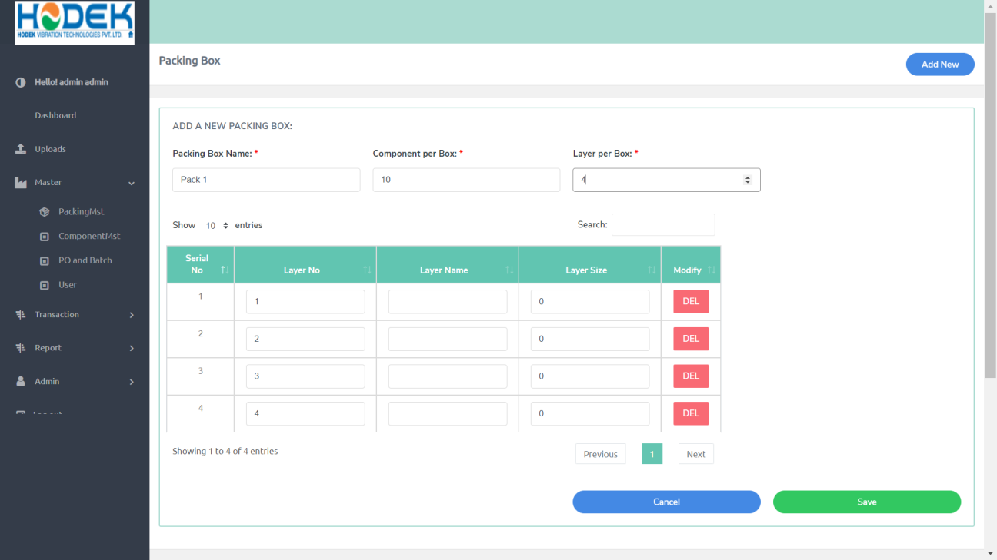

*Image No : 6*

* + 1. **Description**

This will used to managed packing Box module ,from here login user can view packing box details add new updated and etc,

As in *Image No : 5* this page will come on, when click on master --> Packing Box,first of all in this page you can see list of Packing box,from here you can change a status and as will as update details of exiting

As in *Image No : 6*  you can add new entry on click of “Add New ” on top of page after click on add new this page will open ,after that you need to add details ,after that need click save button ,then you get status toaster

Here if you add 4 layer per box then you need to give name to each layer ,and as well as count of each of layer

Total count of each layer must be equal to “component per box”:

* 1. **PO and Batches**
     1. **Screen**

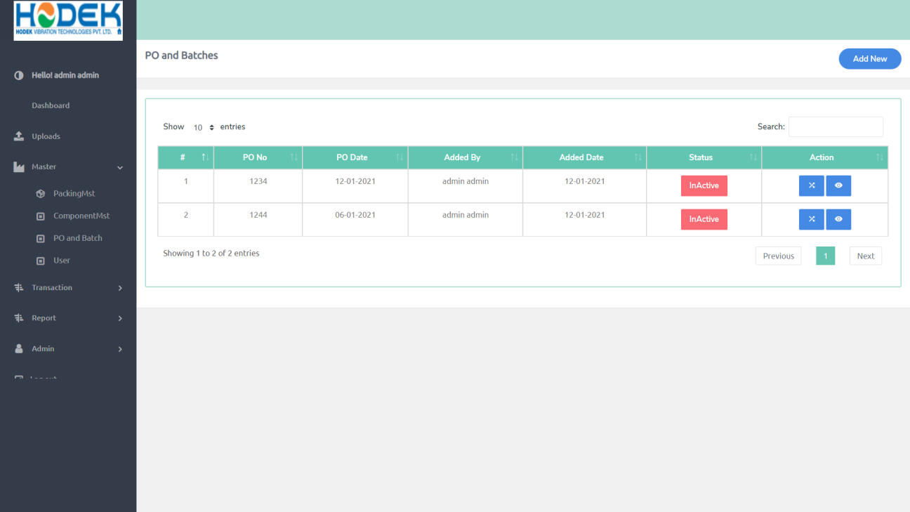

*Image No : 7*

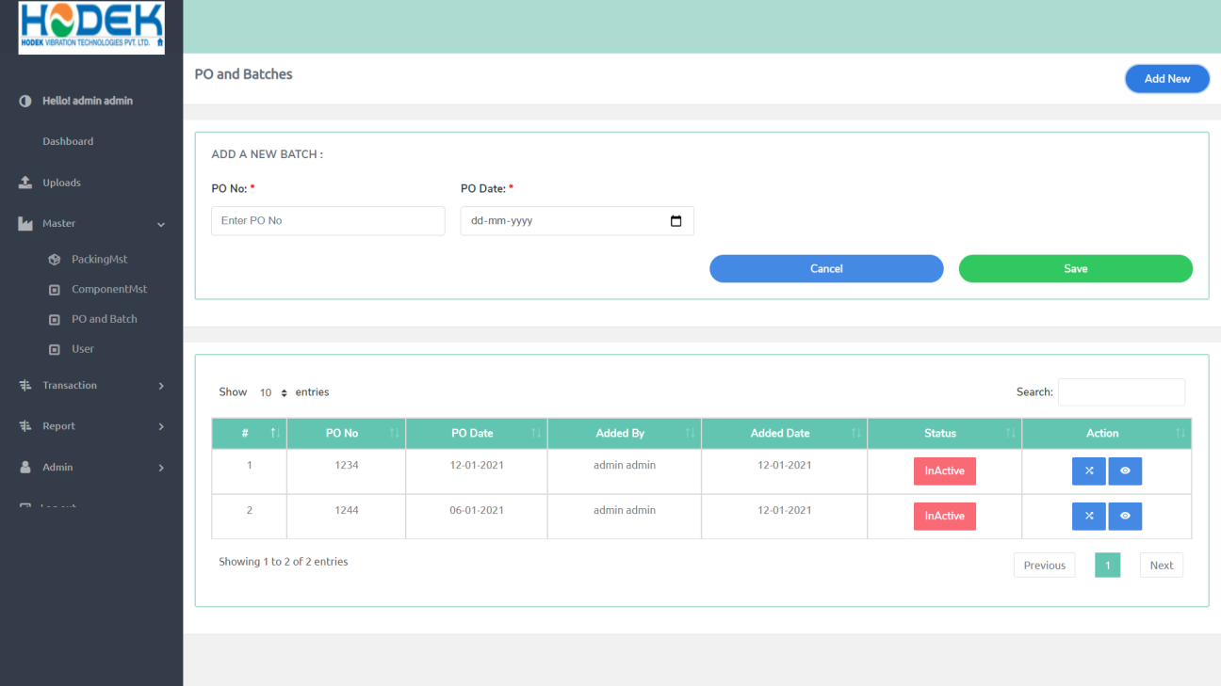

*Image No : 8*

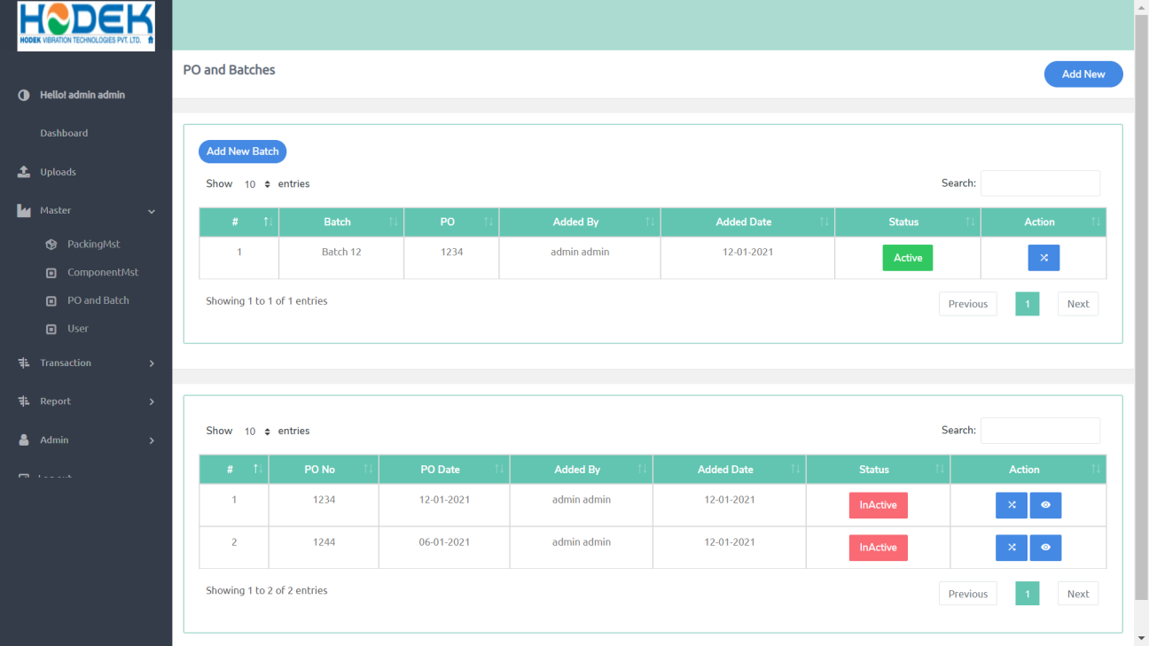

*Image No :9*

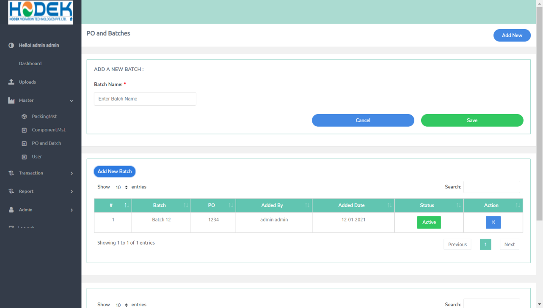

# 

*Image No :10*

* + 1. **Description**

This will used to managed Po and Batch module ,from here login user can view PO details add new and change status and view batches ,

As in *Image No : 7* this page will come on, when click on master --> Packing Box,first of all in this page you can see list of PO ,from here you can change a status of exiting

As in *Image No : 8*  you can add new entry on click of “Add New ” on top of page after click on add new this page will open ,after that you need to add details ,after that need click save button ,then you get status toaster

At a time only one Po can be active only

As in *Image No : 9*  you can view batches according to PO , and from here you can change status of batch ,Every PO has at least one active batch and at a time only one batch can be active

As in *Image No : 10*  you can add new entry for batch on click of “Add New ” on top of page after click on add new this page will open ,after that you need to add details ,after that need click save button ,then you get status toaster

* 1. **User**
     1. **Screen**

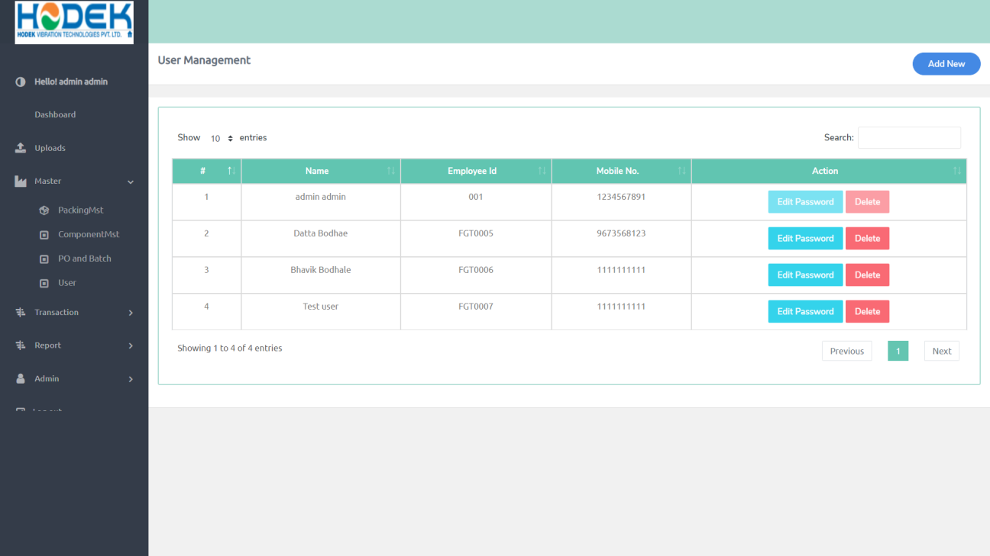

*Image No :11*

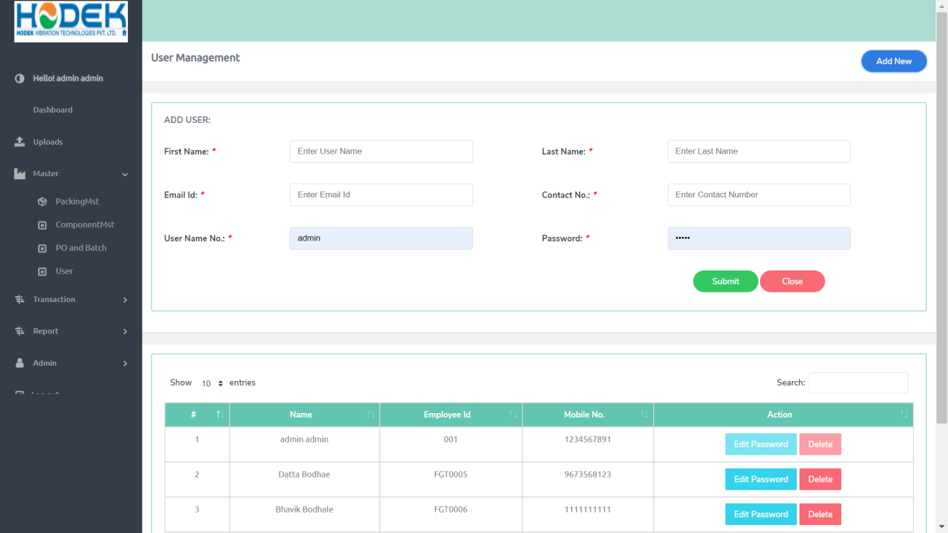

*Image No :12*

* + 1. **Description**

This will used to managed user module ,from here login user can view User details add new and delete

As in *Image No : 11* this page will come on, when click on master --> user ,first of all in this page you can see list of User,from here you can delete /Update of exiting

As in *Image No : 8*  you can add new entry on click of “Add New ” on top of page after click on add new this page will open ,after that you need to add details ,after that need click save button ,then you get status toaster

1. **Upload**
   1. **Component** 
      1. **Screen**

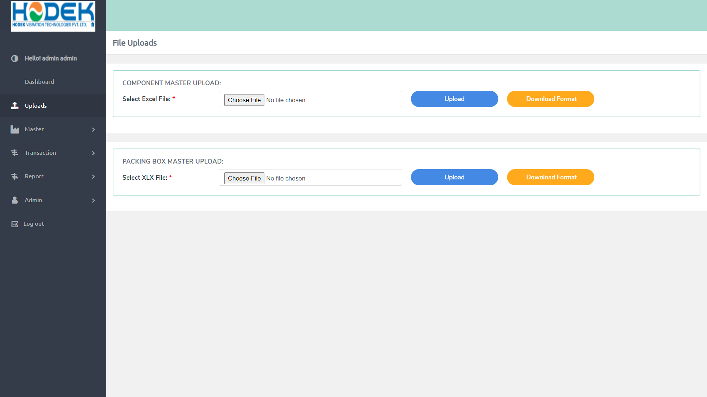

*Image No :11*

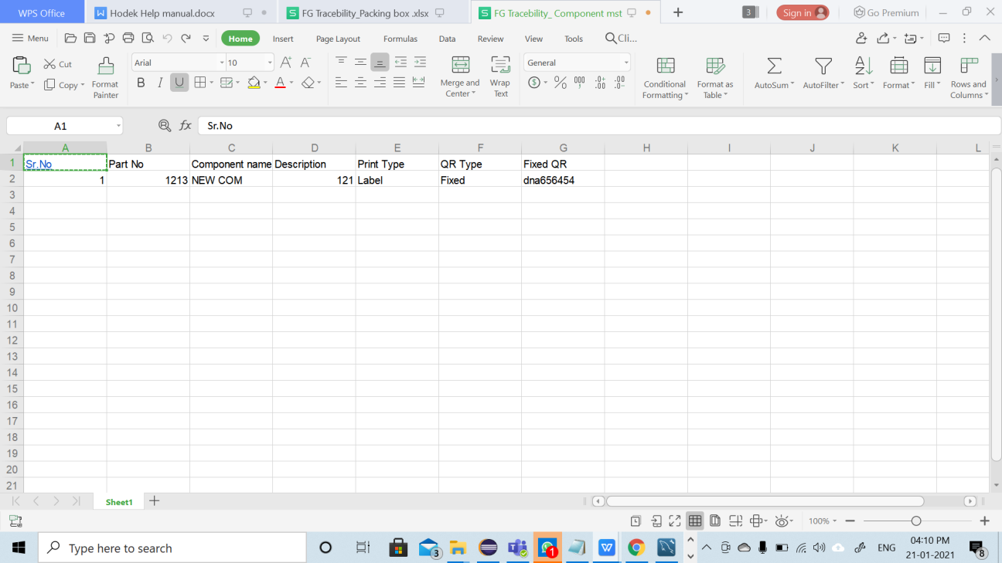

*Image No :12*

* + 1. **Description**

This will used to managed Upload module ,from here login user can upload component list by Excel ,

To avoid Lost of manual entry for Component we provide functionality to add no component data from excel to to direct our application in one transaction only

As in *Image No : 11* to upload component you need fill required data in excel with specific format only to download format excel you need to click “Download format ” Download format has showed in *Image No : 12*

After filling data in excel sheet you need to click om choose file then click on upload ,after that you will get status toaster

* 1. **Packing Box**
     1. **Screen**



*Image No :13*

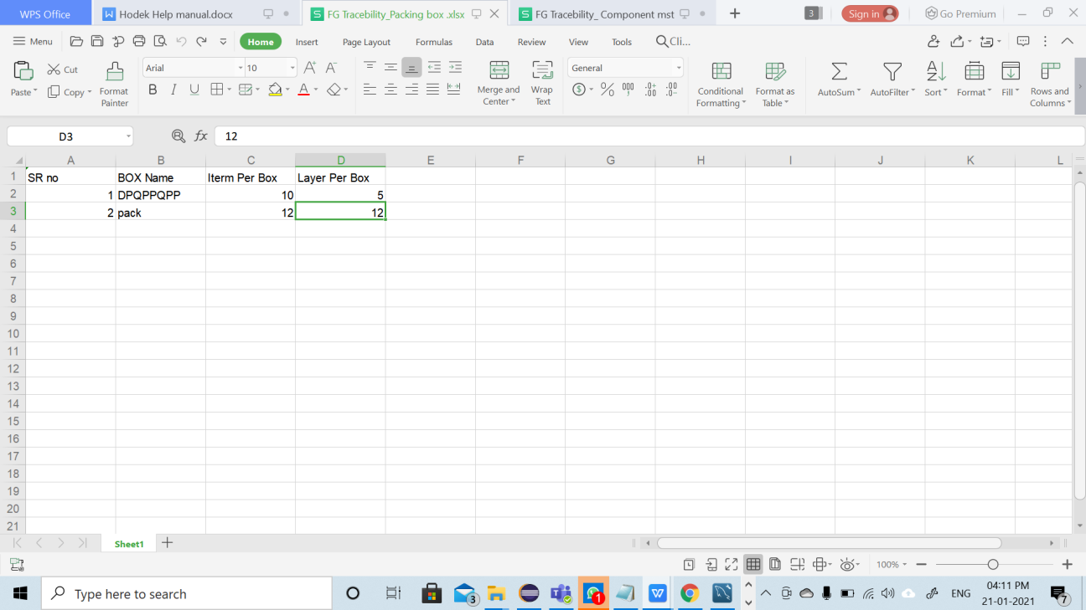

*Image No :14*

* + 1. **Description**

This will used to managed Upload module ,from here login user can upload Packing Box list by Excel ,

To avoid Lost of manual entry for Packing Box we provide functionality to add no of packing box data from excel to to direct our application in one transaction only

As in *Image No : 13* to upload Packing Box you need fill required data in excel with specific format only to download format excel you need to click “Download format ” Download format has showed in *mage No : 14*

After filling data in excel sheet you need to click om choose file then click on upload ,after that you will get status toaster

1. **Transaction**
   1. **QR Code Generation**
      1. **Screen**

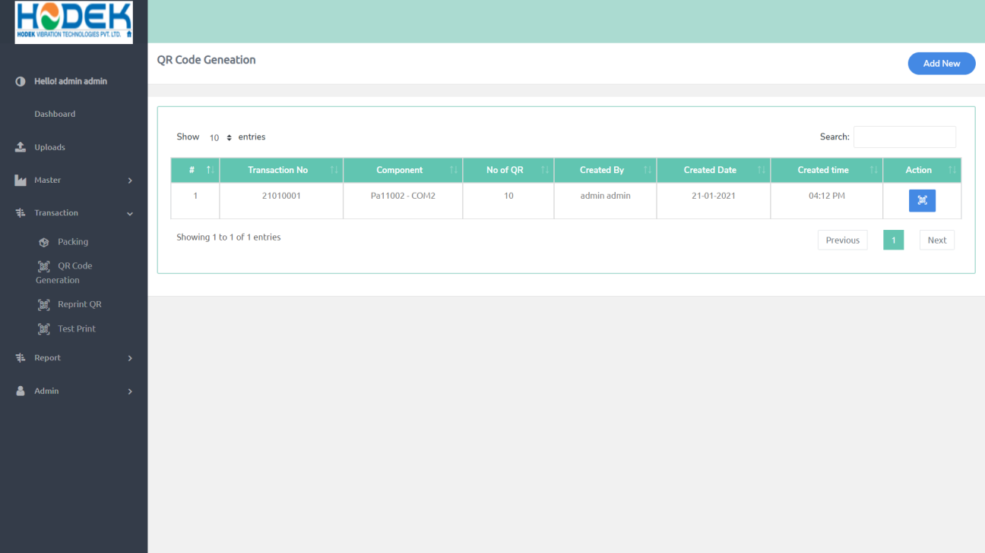

*Image No :15*

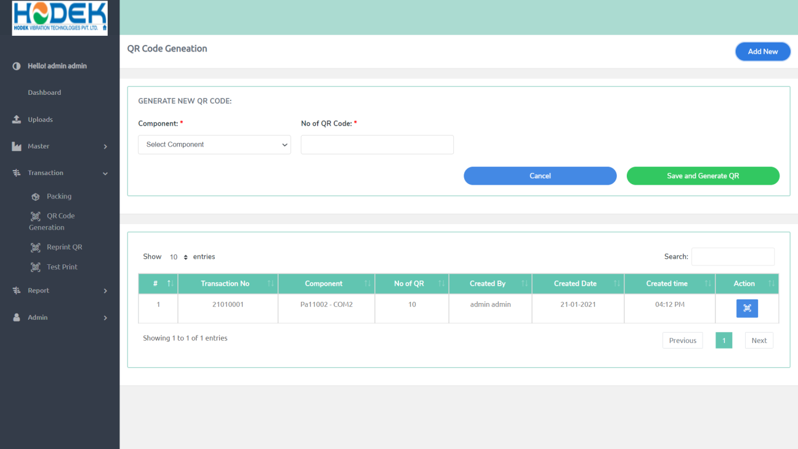

*Image No :16*

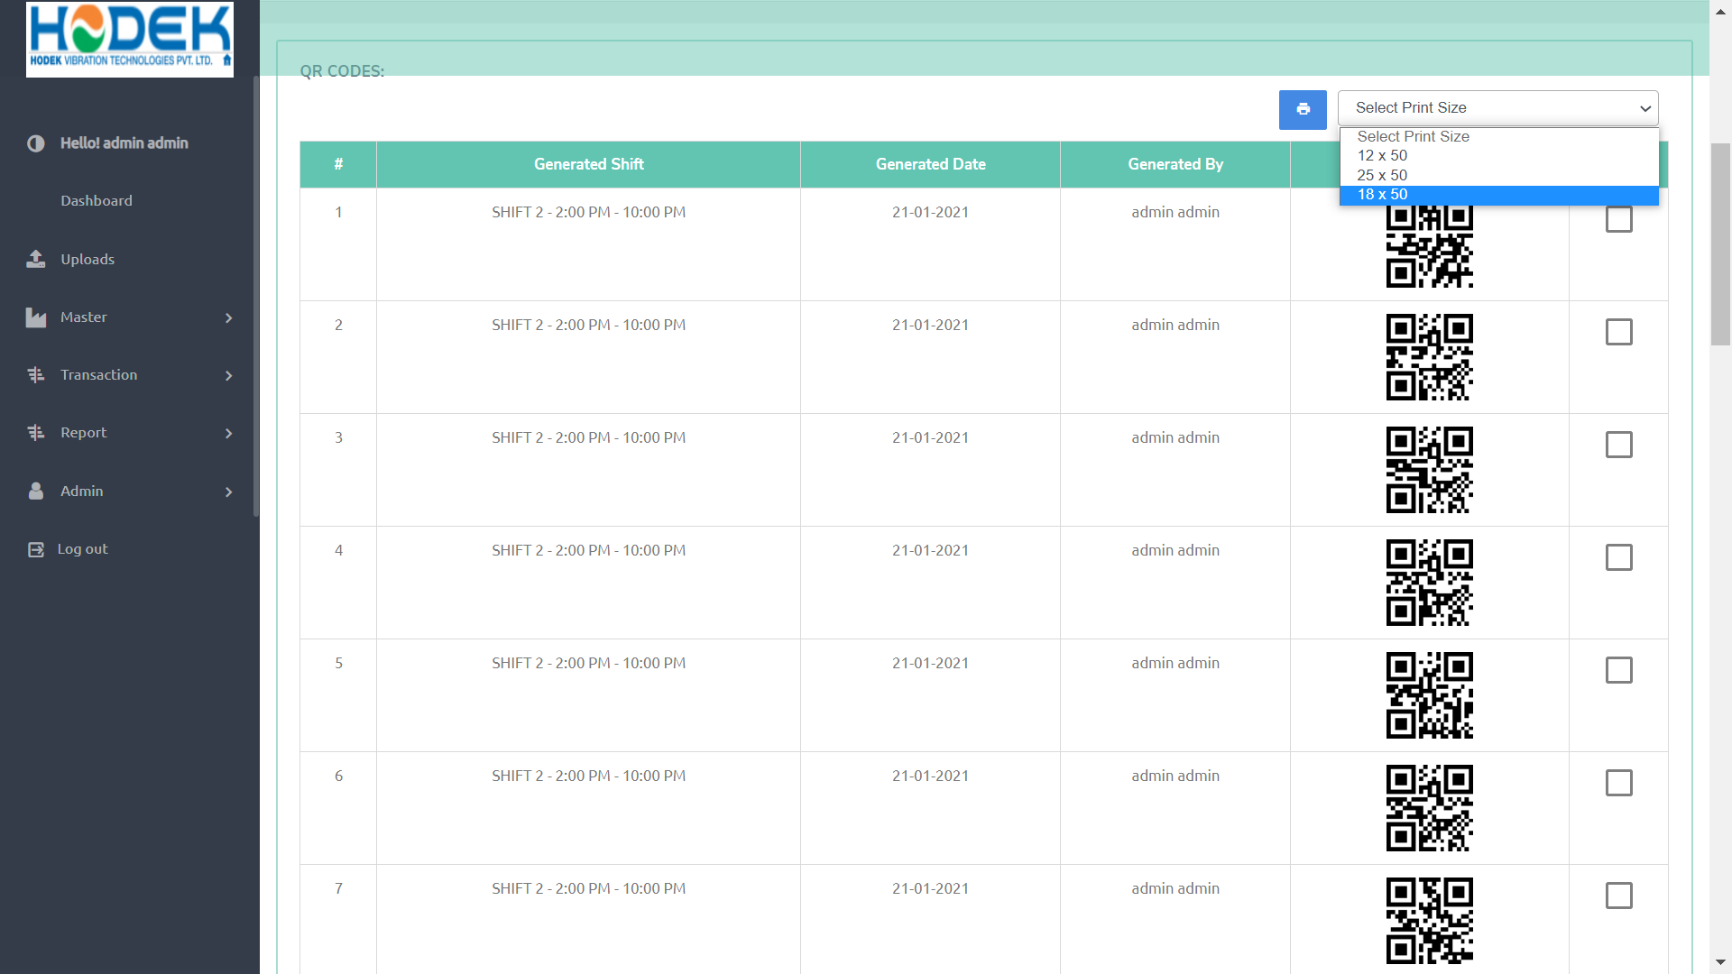

*Image No :17*

* + 1. **Description**

This will used to managed QR Code Generation module ,from here login user can generate a QR Code ,

As in *Image No : 15* this page will come on, when click on Transaction --> QR Code Generator ,first of all in this page you can see list of Qr Code Generator Transaction ,from here you can View Qr Code

As in *Image No : 16*  you can add new entry on click of “Add New ” on top of page after click on add new this page will open ,after that you need to add details ,after that need click save button ,then you get status toaster

As in *Image No : 17*  you can view QR code for transaction ,as well you can print from here ,by clicking check box them select a print size after that click on print button

From here you print QR code only once ,

* 1. **Packing** 
     1. **Screen**

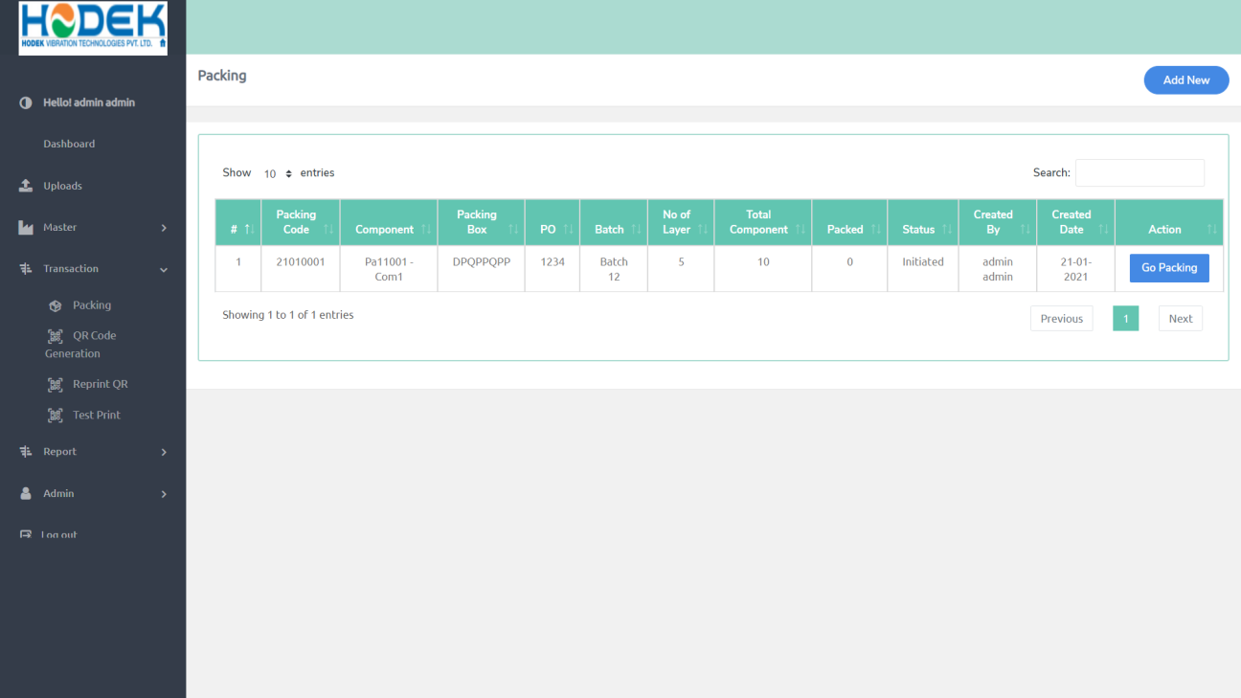

*Image No :18*

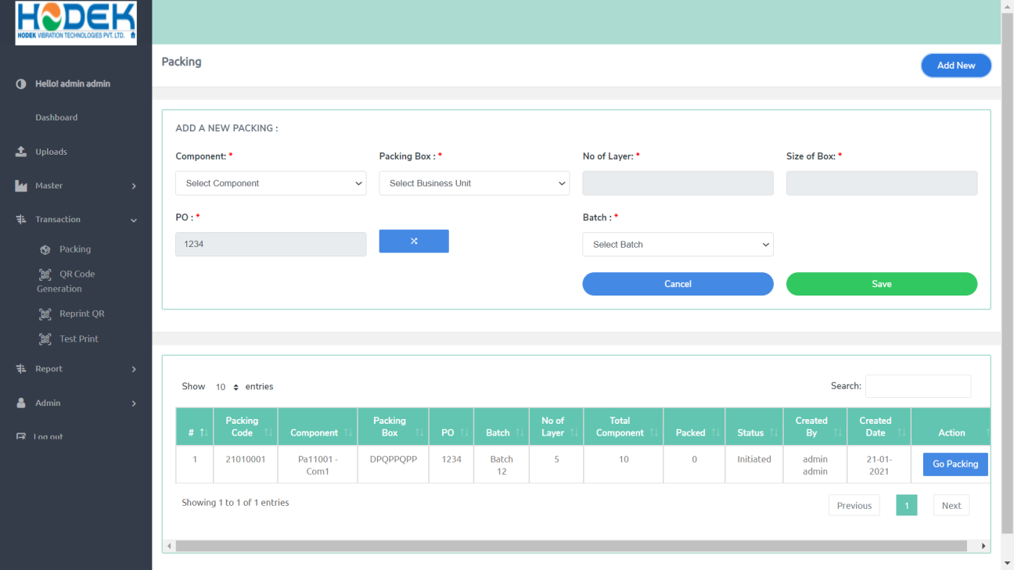

*Image No :19*

* + 1. **Description**

This will used to managed Packing ,from here login user can Start packing

As in *Image No : 18* this page will come on, when click on Transaction -->Packing ,After that you see the list of packing which is created ,and as well as you can go to packing window by clicking “Go Packing ”

As in *Image No : 19* this page will come on,

* 1. **Reprint**
     1. **Screen**

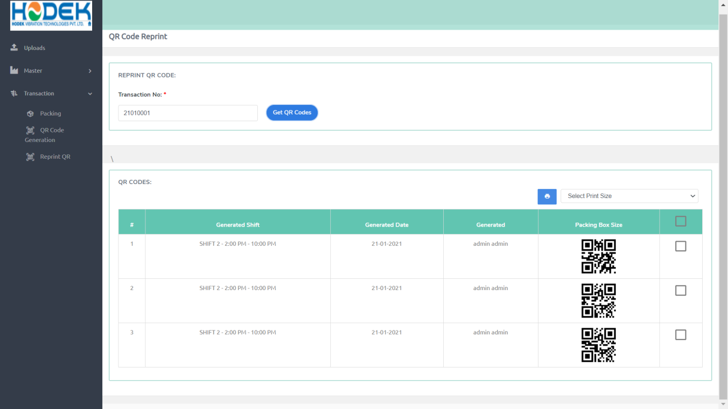

*Image No :20*

* + 1. **Description**

This will used to managed Reprint QR Code ,from here login user can Reprint a QR Code ,

As in *Image No : 20* this page will come on, when click on Transaction --> Reprint QR Code ,After that you need to enter a transaction no Which is generated in “QR Code Generation ” and then click “Get QR Codes”,

Here in list only those Qr Code come which is already Print from

QR Code generator

* 1. **Test Print** 
     1. **Screen**

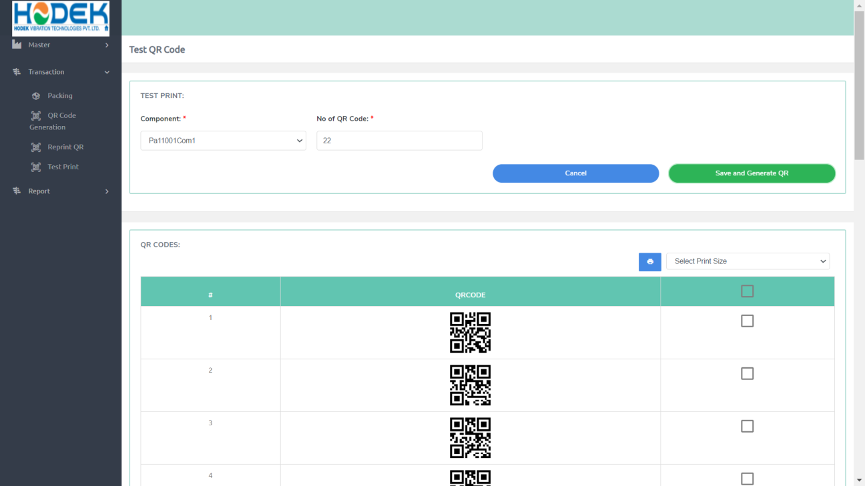

*Image No :19*

* + 1. **Description**

This will used to managed Reprint QR Code ,from here login user can Reprint a QR Code ,

As in *Image No : 20* this page will come on, when click on Transaction --> Reprint QR Code ,After that you need to enter a transaction no Which is generated in “QR Code Generation ” and then click “Get QR Codes”,

Here in list only those Qr Code come which is already Print from

QR Code generator

1. **Admin**
   1. **Role Management** 
      1. **Screen**

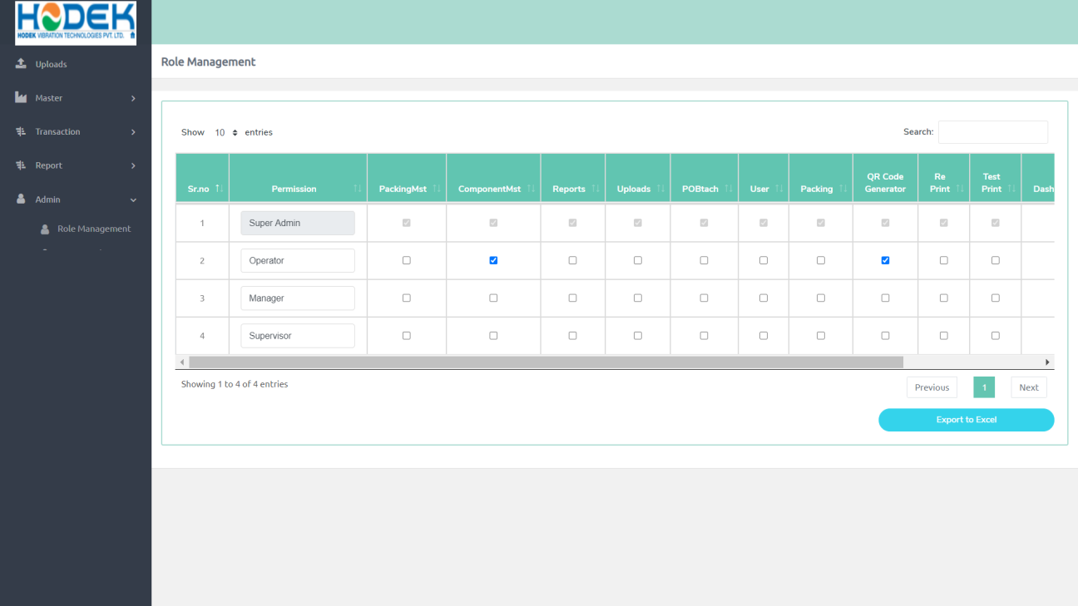

*Image No :20*

* + 1. **Description**
  1. **User Role**
     1. **Screen**

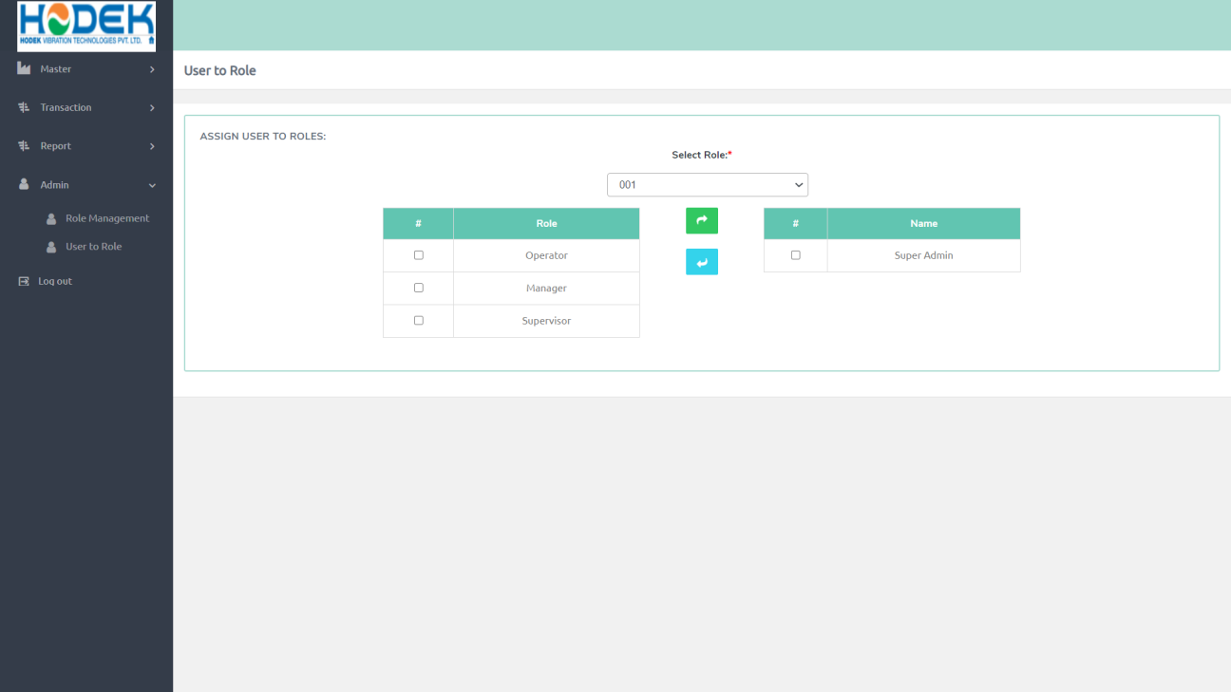

*Image No :21*

* + 1. **Description**

1. **Report**
   1. **User Activity Log** 
      1. **Screen**

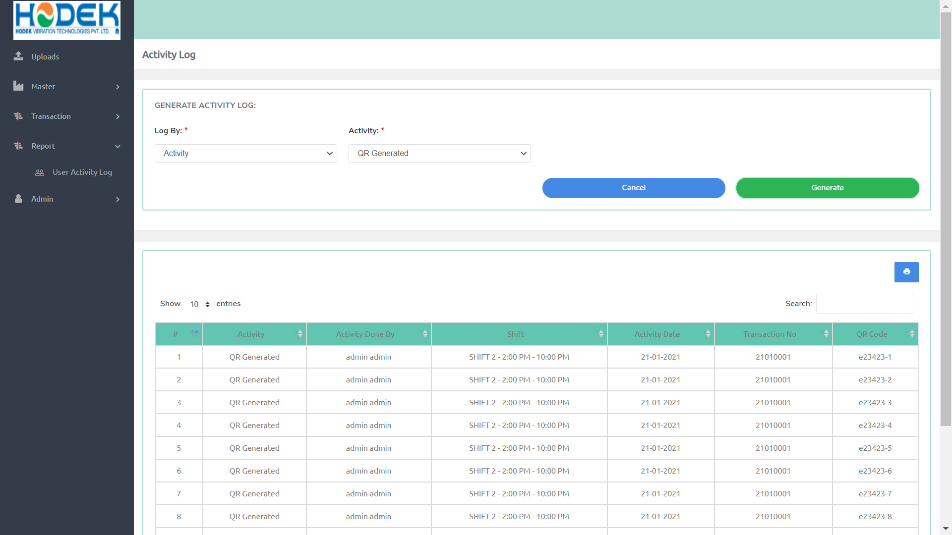

*Image No :22*

* + 1. **Description**

1. **Dashboard**
   * 1. **Screen**



*Image No :23*

* + 1. **Description**